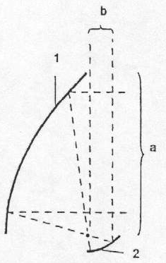
Innovative modular foldable concentrating solar energy system

I. Detailed description of the drawings

Fig. 1. Typical assembly of reflectors of the Cassegrain type

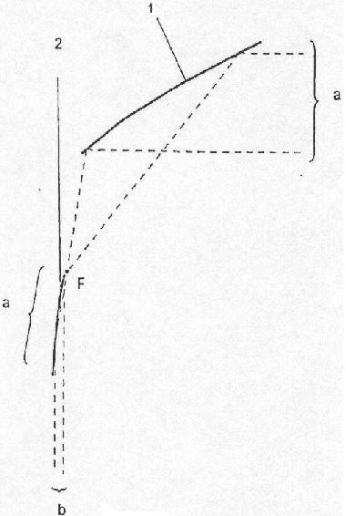
The classical optical concentrating system in the art (typical assembly of reflectors of the Cassegrain type), as shown in Fig. 1, comprises concentrating parabolic surface 1 with a focus (focal line, in case of cylindrical surfaces) F coinciding with the focus of the collimating parabola 2. The incident parallel light rays of size a in Fig. 1 fall upon the reflective surface of the concentrating parabola 1 and are concentrated at the focus (focal line) F. The concentrating ratio a/b to the outgoing collimated light beam can be changed by varying the parameter of the collimating parabola 2. By rotating the collimating parabolic reflective surface 2 around the focus (focal line) F, the outgoing light beam changes only its path, without changing the concentration of the collimated light rays. Some of the problems of this widely known system are: the first one is the need of cooling the collimating surface 2, which, as a rule, is much smaller than the concentrating one 1. It can be resolved by applying forced cooling, by thermally coupling the collimating 2 to the concentrating 1 parabolic surface as well as by ensuring additional cooling surface. The problem can also be resolved by enlarging the area of the collimating surface 2 to allow for maintaining the heating within permissible limits, as is shown in Fig. 2. The other problem is the overshadowing of a portion of the concentrating parabolic surface 1 and a portion of useful incident light rays is lost while the collimated surface 2 heats additionally. As it is shown in the Fig. 3, this problem can also be resolved.

Fig. 2 is an embodiment of Fig. 1, but the collimating parabolic surface 2 has the area of size a, commensurate to the aperture of the concentrating parabolic surface 1. In this case, to realize the same concentration of incident light rays, as in Fig. 1, the parameter of the collimating parabola of the surface 2 should be much smaller than that in Fig. 1. In this way the heating of the collimating parabolic surface 2 is practically commensurate to that of the concentrating parabolic surface 1 from Fig. 1. If needed, the area of the collimating parabolic surface 2 can be enlarged depending on the needed dissipated heat power. This construction allows such positioning of the collimating parabolic surface 2 so that it is located at a sufficient distance from the caustic point (line) F. In case the collimating parabolic surface 2 is located opposite to the incident light rays both parabolic surfaces could be manufactured as a module. In this way the preciseness of the mutual location of both parabolic surfaces is guaranteed in the process of manufacturing.
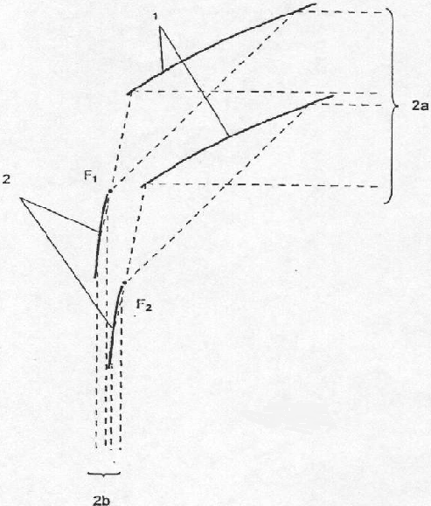
Fig. 3 shows a system comprising of two identical pairs of parabolas, shown in Fig. 2, with coinciding foci (focal lines) F_{i}. The collimating parabolic surface 2 with focus (focal line) F₁ is mounted on the rear side (invisible for incident light rays) of the concentrating parabolic surface 1 with a focus (focal line) F₂. This type of positioning provides for greater space and size of the collimating parabolic surface 2 , as well as for adding of additional dissipating surfaces. The outgoing light beams are parallel to each other and practically touch each other, i.e. they are summed up. In this way the incident light rays of size 2a are transformed into the outgoing light beam of size 2b.
In this way optical concentrating systems of similar components can be assembled without restrictions as to the size. The system can fold down when necessary, as shown in Fig. 16. This approach remains the same with all other suggested constructions.
On first thought, the idea of folding and unfolding in working (erected) position such construction may seem heretical. But as shown in Fig. 4 and Fig. 5, this problem can be resolved in principle, especially where trough-shaped surfaces are concerned. The elements, which have the reflective surfaces with the shape of the concentrating 1 and collimating 2 parabolas, are attached to the moving part 9, which can be moved away freely along the slide-ways 8. Positioning can be performed with greatest precision by supports 10 and 11. Supports 10 and 11 are located on carriers 13 at the right places with the required precision and it is maintained during the positioning of the relevant elements. When the relevant element needs to be appropriately positioned, it has simply to be pressed to its relevant support with the appropriate force and the required precision of positioning will be achieved. Bumpers 12 protect the construction against impact. The reflective surface components having the shape of all other couples of curves, described above, can also be located in this way.

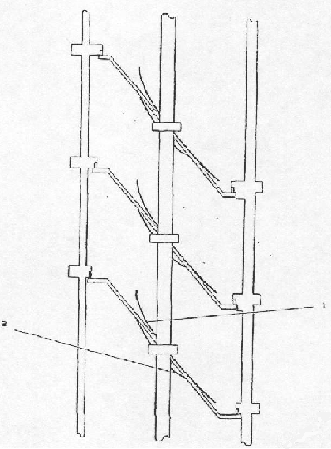
Fig. 4
The system in working (erected) position

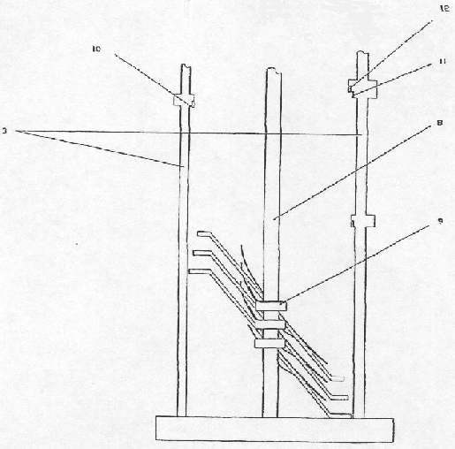
Fig 5.
The system in the save (folded) position

II. Detailed description of the animation

The animation could be started (of course, after unzipping it) by clicking on the file movie.exe. It needs Flash player on your computer.

The scene 1 shows the well known and proven Cassegrain assembly of concentrating and collimating mirrors. There are several reasons this assembly not to be used for solar energy concentrating purposes:
The collimating mirror is very quickly heated to the very big temperatures and will be melted, if the appropriate forced cooling will not be used (scene 2). But this technical decision is impractical for the aforementioned purposes – it makes the device so expensive, that practically the system will be unsoldable. So that such technical solution must be found, which to ensure the passive cooling of the collimating mirror. The first step was shown in the scene 3 – if to the first concentrating module (consisting concentrating and collimating mirrors), the second one is added in such a way, so that the first collimating mirror is thermally connected to the second concentrating mirror. In this way the thermal problems could be avoided, the modules are equal, (relatively small to be precisely molded) and don’t disturb each other. The big concentrating mirror hides the collimating one. It seems that the problem could be resolved in this way. But as it often happens when you resolve one problem another one appears. One of these problems is the mutual disposition between the concentrating and collimating mirrors – it must be guaranteed with big preciseness. So that another solution is searched, which to resolve all of the aforementioned and this problem together. One attempt is shown in the scene 4 – the surface of the collimating mirror is enlarged enough to be cooled passively and in the same way it continue to collimate the concentrating solar rays. But in this case it would hinder the incoming solar rays to reach the concentrating mirror from the next module. So that the collimating mirror must be hidden behind the concentrating one – scene 5.
Scene 6 shows the final module, which resolve all the problems. With such kind equal elements the concentrating system could be build as big as it is possible (scenes 7 and 8). After so many transformations the final module remains still Cassegrain assembly of mirrors.
The problem with the strong winds and the other harsh environmental conditions could be resolved by folding down the whole system in the save position. In this way the big surface could be reduced several times and the big efforts, which the whole construction must to endure, would be avoided. The solution is shown in the scene 9 – the modules allow this folding. The working position of the modules is ensured by the relevant system of supports.
The next scene 10 shows how the system works – the concentrated solar rays are very close to the concentrated area. In this way the construction of the whole system is additionally simplified.
The scene 11 shows how the big number of concentrating systems works in the village or a town. In solar days this system could satisfy the all the needs of the home and the excess of the accepted energy could be gathered in the common electric generator.
This is one of the cheapest ways for using solar energy with the existing technologies (for example, the final element is practically used by the Solargenix in the Cramer Junction, California) (Fig. 9-13).
The modules could be build from the molded members in the described modified Cassegrain assembly form. The members can be molded in the similar (but very simplified) manner like the molded aspherical lenses, produced by Edmund Industrial Optics (http://www.edmundoptics.com/), Melles Griot Inc (http://www.mellesgriot.com/), Newport Corporation (http://www.newport.com/), Rolyn Optics Company (http://www.rolyn.com/), etc. The high efficient reflective folio manufactured by 3M, Alanod or other companies could be used for stretchening between molded and fixed members. In this way the final element can be build.

III. Brief review of the concentrating state-of-the-art solar energy concentrating systems
Introduction
The basic concepts and ideas of photovoltaics using concentrated sun light (CPV) have been published and patented in the 70’s and 80’s of last century. So they are about as old as the basic principles of flat panel PV technology. But existed CPV is not well suited for small industrial applications. In the beginning of terrestrial PV applications, about 30 % of solar cell production was used in industrial and consumer products like watches, pocket calculators, traffic applications, solar home systems etc., where often only a few W_{p} are necessary for electric powering and where tracking is not possible. So while these applications were historically a strong motor for the growth of PV production, CPV could not take part in this market section. CPV is also not well suited for grid connected roof systems. The application of PV modules in grid connected systems of a few kW_{p} size mounted on or integrated in the roof surface of private homes was and still is one of the biggest stimulus of the PV market due to support of several government programs world wide. Here again the small size of systems, the necessity of tracking (i.e. of moving parts) and the need they to withstand to the strong winds makes CPV not a good option.
CPV offers such a large variety of technical possibilities but R&D is still in the state of finding the best options. CPV systems promise a number of advantages if they are built with a size > 10 kW_{p} and at big enough fabrication volume (> 10 MW_{p}/y) as will be described below.
Nowadays rooftop installation is currently becoming a practical goal for a new generation of CPV.

1. Solar lighting concentrating systems
Once concentrated, the solar energy could be used not only for producing electricity, but for heating and lighting. This method of lighting is already proved by the solar lighting system based on a design developed by Oak Ridge National Laboratory and built at Utah State University. The system captures the full-spectrum direct sunlight and delivers it directly instead of converting it into electricity and then into artificial light.
The lighting system consists of a two-axis solar tracking system, a 1m parabolic mirror to concentrate sunlight, an elliptical secondary mirror to filter the infrared (IR) and re-direct the visible (typical assembly of reflectors of the Cassegrain type), and a fiber-optic bundle for transmission (see Fig. 6). An infrared-photovoltaic (IR-PV) array placed behind the elliptical mirror could be used to generate electrical power.
Pure visible light – without the uncomfortable infrared or the damaging ultraviolet – is conducted through the optical fibers into the building.

System HSL 3000
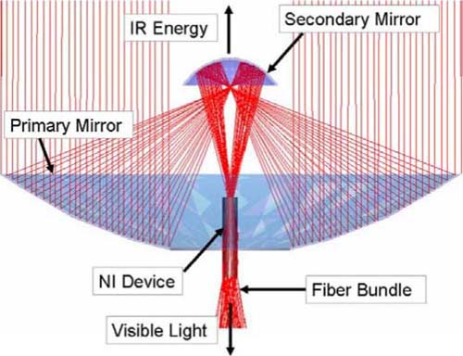
The fibers could feed concentrated light from the system HSL 3000 into an acrylic rod, the non-electrical equivalent of the fluorescent tubes between which it is sandwiched in the commercial hybrid lighting fixture. The sunlight, which would otherwise continue in a straight line, is diffused outward into the room by means of hundreds of tiny scratches on the surface of the rod.

Fig. 6. The solar lighting system concentrates rays directed by primary and secondary mirrors (Cassegrain assembly) to full-spectrum output through a fiber optic bundle. NI: Non-imaging. IR: Infrared

One HSL 3000 is capable of lighting approximately 1000 square feet.
The HSL 3000 is scheduled for release early in 2007, and is initially priced at about $8,000 USD.
Although Sunlight Direct has not specified the cost of installation – other than to imply that it would involve extra money you would not be paying if doing it yourself – having professionals do the work would obviously add to the price of the system. Basing a rough guess on the rates charged by other professional trades, this could amount to an additional $1000 or more, depending on the size of the house and the number of areas to be lighted. But the safety factor may make this worth the extra cost
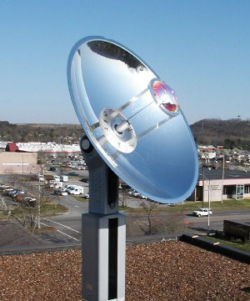
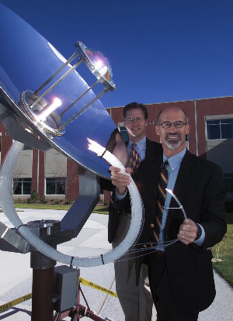
Fig. 7. The HSL 3000, a hybrid lighting system developed by Sunlight Direct, carries the actual light of the sun indoors. The system’s 48-inch primary mirror concentrates light into a secondary mirror, which strips away the infrared and ultraviolet components, and directs the visible light into the receiver. A tracking system has two motors governed by a GPS microprocessor, which can calculate the position of the sun within half a degree.

Fig. 8. It’s hard not to fantasize about a kitchen console with heat-tolerant optical rods of various thicknesses depending on the volume to be heated. These could be inserted into anything that requires to be boiled.

With the sun’s power focused, a lot of daytime food preparation could be done without fuel.
Early designs of the hybrid system included thermal photovoltaic cells to take advantage of the IR energy that is not currently being used by the HSL 3000. This idea was abandoned due to the cost of these cells and the low power output, but might be revisited if the cost comes down. This might become an add-on in future. If so, the basic system should be designed so that additional features can be simply plugged in without having to re-tool or to modify the already-installed solar collector.
As you can see prof. Dely, this company uses the same principles, as they are used in my construction.

2. Solar thermal electric systems
Parabolic trough concentrating systems
Fig. 9. A parabolic trough concentrator focuses solar radiation onto a linear receiver when faced directly at the sun

Each solar collector has a linear parabolic shaped reflector that focuses the sun’s direct beam radiation on a linear receiver located at the focus of the parabola. The collectors track the sun from east to west during the day to ensure that the sun is continuously focused on the linear receiver. The solar field is modular and is composed of many parallel rows of solar collectors aligned on a north-south horizontal axis (Fig. 10).

Fig, 10.

The receivers convert energy from the sun into electricity by using concentrated solar radiation from the plant’s parabolic mirrors to increase the temperature of the thermo-oil heat transfer fluid (usually artificial oil) flowing through the receiver to 395ºC. This heated fluid is then used to turn water into steam, which drives a turbine and generates electricity (Fig. 11). In this way one of the cheapest electricity from the solar energy is generated.
Parabolic trough technology is currently the most proven of the solar thermal electric technologies. The first large commercial-scale solar power plant has been operating in the California Mojave Desert since 1984 (SEGS I). The nine plants, which continue to operate daily, range in size from 14 to 80 megawatts (MW) and represent a total of 354 MW of installed electric generating capacity.
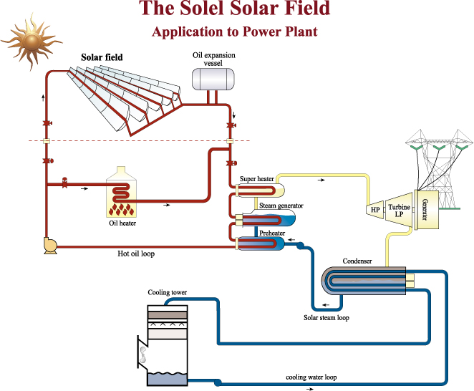
Fig. 11.

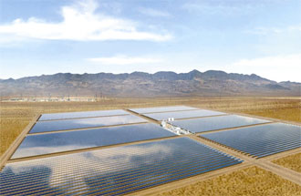
The new 64MW Nevada Solar One power plant will follows in the steps of the 354MW solar thermal power plants and will use new technologies to capture even more energy from the sun: Amendment for expansion to 64 MW was approved in June 5, 2005. In the February 11, 2006 SCHOTT officially introduced to the public its new PTR 70® solar receiver, which will lie at the heart of Solargenix’s new power plant.
The SCHOTT receivers convert energy from the sun into electricity by using concentrated solar radiation from the plant’s parabolic mirrors to increase the temperature of the thermo-oil heat transfer fluid flowing through the receiver.

Fig, 12. The aerial view of the 2.5 km² power plant in the California Mojave Desert.

Solargenics has been developed the Roof Integrated “Tracking” Solar Systems for mid and high temperatures applications to meet a wide range of energy needs: electricity generation, hot water and space heating, absorption cooling. In fact the process is “co-generating” as it is shown in the fig. 13.

Fig. 13: The power roof generates temperatures up to 550ºC

The followed several pictures illustrated how some of the most important stages of the construction look like:

Parabolic dish concentrating systems
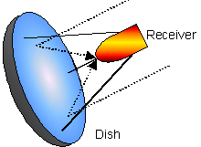

Fig. 14. A paraboloidal dish concentrator focuses solar radiation onto a point focus receiver

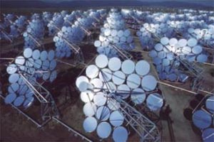
The high concentration ratios achievable with dish concentrators allow for efficient operation at high temperatures. Stirling cycle engines are well suited to construction at the size needed for operation on single dish systems and they function with good efficiency with receiver temperatures in the range 650ºC to 800ºC. To achieve good power to weight ratios, working gas pressures in the range 5 – 20MPa are employed and use of either the high conductivity gases hydrogen or helium gives improved heat transfer. The Advanco corporation and McDonnell Douglas have produced 25kWe dish Stirling units which have achieved solar to electric conversion efficiencies of close to 30%. This represents the maximum solar to net electric conversion efficiency achieved by any solar energy conversion technology.

Fig. 15. Solar Plant 1, 400 dishes producing steam.

The biggest distributed array / central plant solar thermal power system that has been trailed is the “Solarplant 1” system built in Southern California by the “Lajet” consortium in 1983/84. It consisted of 700 dishes with a total collecting area of 30,590m². The dishes generated steam in their cavity receivers, with 600 of the dishes producing saturated steam and others taking the saturated steam and superheating it to 460ºC. The steam was transported through an insulated pipe network to a central steam turbine based generating plant which produced a nominal output of 4.9MWe. The dishes were constructed with multiple stretched membrane mirror elements. The membranes were made from aluminized acrylic film. Unfortunately this film proved not to be very durable, which was a major factor in the plant ceasing operation in 1990.
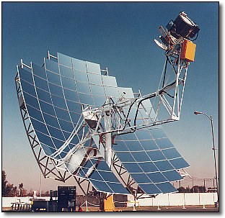
Fig. 16. The SES solar parabolic concentrator is 38 feet in diameter and has 82 mirror facets the size of car hoods. The mirror facets direct solar radiation to a solar receiver that encloses the heater head of the Stirling engine. The PCU is cantilevered 24 feet in front of the mirrors.

Stirling dish technology has been successfully tested for 20 years.
The Stirling dish technology converts thermal energy to electricity by using a mirror array to focus the sun’s rays on the receiver end of a Stirling engine. Each panel tracks azimuth and elevation to keep the sun’s rays focused at greatest intensity possible.
The internal side of the receiver then heats hydrogen gas which expands. The pressure created by the expanding gas drives a piston, crankshaft, and drive-shaft assembly much like those found in internal combustion engines but without igniting the gas. The drive shaft turns a small electricity generator. The entire energy-conversion process takes place within a canister the size of an oil barrel. The process requires no water and the engine is emission-free.
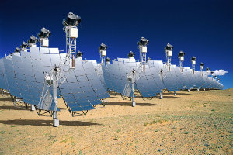
Tests conducted by SCE and the Sandia National Laboratories have shown that the Stirling dish technology is almost twice as efficient as other solar technologies. These include parabolic troughs which use the sun’s heat to create steam that drives turbines similar to those found in conventional power plants, and photovoltaic cells which convert sunlight directly into electricity by means of semiconducting materials.
Fig. 17. Artist’s rendering of a large installation of the Stirling dish arrays

In August 2005 SES announced a contract with Southern California Edison that will result in construction of a massive, 4,500-acre solar generating station in California .The signed 20-year power purchase agreement, calls for development of a 500-megawatt (MW) solar project in the Mojave Desert northeast of Los Angeles, with an option to expand the project to 850 MW.
The first 500 MW phase, consisting of a 20,000-dish array, will be constructed during a four-year period (Fig. 17.)
In September 2005 Stirling Energy Systems' (SES) announced a 300-900 MW solar power facility for San Diego Gas & Electric (SDG&E) in southern California, which will consist of 12,000 Stirling solar dishes on approximately three square miles in the Imperial Valley of Southern California. SDG&E has options on two future phases that could add up to 600 MW of additional solar energy capacity to SDG&E's resource mix.
The cost for each prototype unit is about $150,000. Once in production SES estimates that the cost could be reduced to less than $50,000 each, which would make the cost of electricity competitive with conventional fuel technologies.

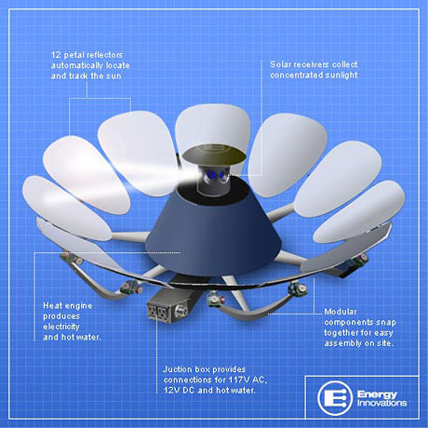
California-based (in Passadena), Energy Innovations (USA) has made several attempts to mount solar concentrating systems on the roof.

Fig. 18. The Stirling-engine Sunflower™
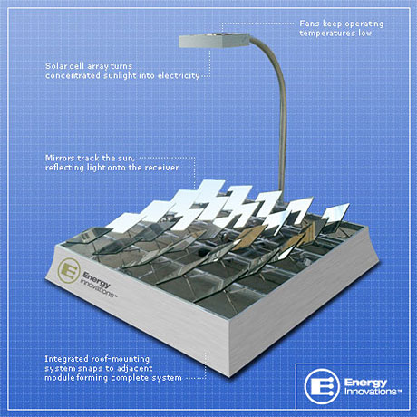
Energy Innovations has made the first attempt to install their Stirling-engine Sunflower™ on the flat roof. It concentrates sunlight to a high temperature using equal very inexpensive and lightweight aluminized plastic petals that are each moved by microprocessor-based servo motors, enabling them to independently track and reflect the sun. At the focus of these petals a compact heat is placed that generates both hot water and electricity and yet contain it all in a stationary, low-profile enclosure.
Fig. 19.
A heliostat is an instrument in which a mirror is automatically moved so that it reflects sunlight in a constant direction. The mirrors track the sun over the course of a day and an arm holds the generating device over the mirror. At the focal point of the heliostat a special PV cell is mounted, designed to withstand and take advantage of high concentrations of solar energy. In addition, a similar configuration could be used to power a Stirling engine. It is also possible a low-cost cells that work under lower levels of concentration (25x) to be installed, but, of coarse, the level of the concentration must also to be reduced.
Fig. 20. Energy Innovations has developed a system for flat roof application. 25 flat mirrors mounted close to ground are individually tracked to reflect their light onto a common receiver area of the same size. So concentration C=25. The system uses c-Si cells.

These concepts are proved in larger-scale installations such as solar farms.

Energy Innovations secured $16.5 million in venture financing on June 29, 2005 to commercialize their rooftop PV solar concentrator systems.

3. Solar concentrating systems used photovoltaics
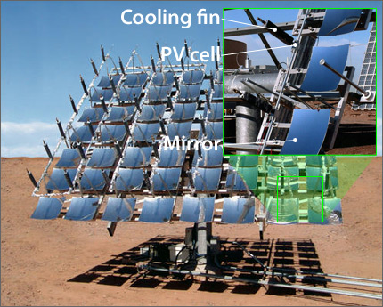

Fig. 21. The MicroDish is made by Concentrating Technologies using Spectrolab solar cells. It is the world's first grid-tied high-concentration CPV system to use the latest high-efficiency cells. The dual-axis tracking modules use small parabolic mirrors to focus sunlight onto high-efficiency multijunction cells. Individual fins extend outward to cool each cell. This MicroDish is supplying electricity to the Arizona Public Service grid.

4. Solar Fresnel lens concentrating systems used photovoltaics
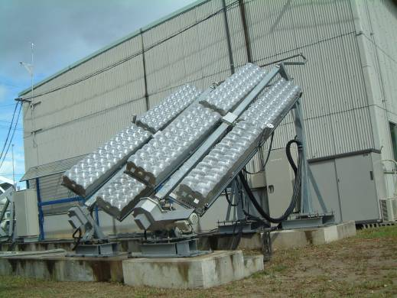

Rooftop installation of new generation of CPV becomes a practical goal for a Japan's and world’s largest PV manufacturer, Sharp, too. It also developed a high-efficiency concentrator for rooftops (see left and Fig. 22.). Japan's densely packed population centers are filled with large apartment buildings that have limited roof space to serve a high density of people. CPV makes sense because, compared to flat-plate PV, concentrating PV can produce more energy in less space. This is important in a country where the cost of electricity is well over 20 cents per kWh.

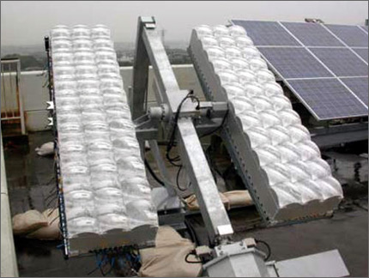
Fig. 22. Daido Steel's Toyohashi 200-watt module is lightweight and uses high-efficiency multijunction cells—perfect for rooftop installation in population-dense places like Japan
They plan a rooftop system with dome Fresnel lenses and C= up to 550 using III-V cells.

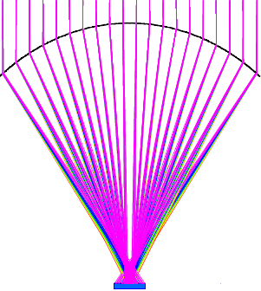

Fig. 23. The symmetrical refraction principle, shown schematically here, is the base for Fresnel lens optical elements used by the mini-dome lens.

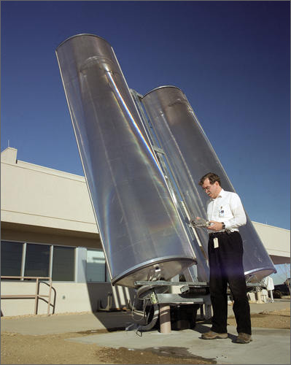

Fig. 24. These single-axis concentrating PV cells use curved optical lenses to focus the sun's light onto a strip of cells inside the module.
The cells are undergoing testing at NREL's Outdoor Test Facility.

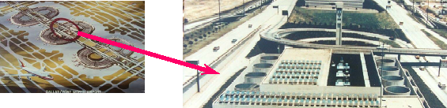

Fig. 25. Dallas/Fort Worth (DFW) International Airport First-Generation 25X Photovoltaic & Thermal System (24 kWe + 120 kWt ) , using single-axis concentrating system, shown in the Fig. 24.

IV. The new offered innovative modular foldable concentrating solar energy system

The main features of the newly developed concentrator are:
- It is built of equal elements. This leads to significant reduction of unit cost if concentrators are produced serially. Preliminary estimates prove that solar systems using the above mentioned concentrator would be at least 2,5 times cheaper than the existing systems with identical power output;
- The equal elements are relatively small, so that it is relatively easy they to be manufactured with the necessarily preciseness;
- The possibility to build concentrators of different sizes, as necessary, out of the equal elements mentioned above, makes them fit and usable in any practical application;
- The construction allows to fold down the concentrator in a stowed (safe) position and to unfold it into working position automatically. The size of concentrators of large usable area in safe position becomes very small. The stowed (safe) position is an effective precaution that allows the system to withstand strong winds and other harsh weather conditions. It also leads to power reduction of the solar tracking system, thus to additional price reduction;
- The concentrator can be assembled in such a way that its focus be situated on the axis of rotation, outside of the receiving surface of the reflectors. Thus the energy receiver can be fixed, therefore, no slip joints or flexible couplings are needed for the working fluid or steam, which generally flow at high temperature and pressure, in case of thermo converting systems. This will additionally reduce the price;
- The receiver will not cast a shadow on the concentrator. Therefore, 100% of the surface of the reflectors will be utilized;
- The design allows different levels of concentration to be achieved;
- The concentrator is relatively light, because of its construction and due to that, it will not need to withstand strong winds.
Due to the successful overall solution of technical shortcomings displayed by existing systems, one might say that this is a second generation in the development of solar energy concentrators. The features of the newly developed concentrator allow for its being mounted on building roofs and serving as a fundamental component for domestically generated energy. In this way many existing buildings can be easily transformed into environmentally friendly houses. Concentrated solar energy can be used simultaneously for production of electricity and for direct heating and lighting, thus providing for a significant portion of daily energy needs. It leads to improved efficiency of the system: there are no energy losses due to transformations of energy from one type to another. On sunny days the excess of the generated energy can be directed to the existing electrical network and be used during nighttime or cloudy days. In this way the need of expensive accumulating devices could be avoided.
The new solar energy system with concentrator could become a widely spread popular product. Currently, the above-mentioned three types of solar concentrators are not widely used, because they are expensive and could not be protected against harsh weather conditions. For example, the concentrating solar power program of the US Department of Energy includes complete testing of the 25-kWatt-dish system at the University of Nevada. Such a collector if it were required to meet ANSI standards for buildings (A58.1-1982), would have to survive a total force of 350.000 N (wind velocity 90 m/s). Wind pressure is an overwhelming concern in the design of moving solar concentrators because the dish construction is monolith, not foldable.
Middle class customers will be the targeted potential buyers of the new product. As mentioned above, the technical characteristics allow for the wide spread use of the system not only in southern countries or sites, located at a considerable distance from power distribution networks.
This concentrator can be used not only for smaller 10 to 20 kW generators, but for industrial power plants delivering several megawatts of output as well. Large concentrating systems could be constructed to meet the needs of large energy consumers, e.g., thermoelectric power stations or heating plants.
It could serve as the basis for worldwide environmentally friendly use of solar energy. It could grow to be a profitable business for both manufacturers and consumers, while having beneficial effect on the environment, too.

The project
Parabolic dish technology is the lowest cost solar power option available today, providing megawatt-scale installations. The new developed system added new features to the concentrating technology, making it hibrid and in this way create an excellent candidate for power projects in towns and remote areas.
The most recent technology, hybrid use of concentrated sunlight, collects sunlight and converts it direct in DC electricity, heat the receiver pipe through which synthetic oil (or other heat carrier) circulates, or routs it through optical fibers into buildings, where it is combined with electric light in "hybrid" light fixtures.
- Sensors keep the room at a steady lighting level by adjusting the electric lights based on the sunlight available. This new generation of solar lighting combines both electric and solar power. Hybrid solar lighting pipes sunlight directly to the light fixture and no energy conversions are necessary, therefore the process is much more efficient.
- Thermal sensors keep on room or the boiled water at a steady temperature level.
- The relatively small (4-8kW) inverter ensure the needs of the home.
- With the excess of the power can be supplied the commn power station.

Excess Energy Home (EEH)
In this way the Excess Energy Home (EEH) can utilize the solar energy to satisfy allmost of its need and additional accepted solar energy could be used. This strategy is better than the conception of Zero Energy Home (ZEH), because the price of the energy would raise nowadays the lowest levels.

Georgi Gushlekov
Tel/Fax: +359 2 897 17 65
Mobill: +359 889 522 546
E-mail: gushlekov@yahoo.com

